**END SEMESTER PROJECT**

**FOCP**

Instructor: Prof. Shah Khalid

**PROJECT TITLE: LIBRARY MANAGEMENT SYSTEM**

**TEAM MEMBERS:**

1. AQIB ALI CMS ID: 512517
2. ALOK KUMAR CMS ID: 513372
3. MUHAMMAD AHMAD CMS ID: 501395

**STATEMENT OF CONTRIBUTION:**

* Member 1. Muhammad Ahmad: Software design, development and testing.
* Member 2. Aqib Ali: Development, debugging and testing.
* Member 3. Alok Kumar: Information gathering, development and documentation.

**BACKROUND:**

Efficient Library Management is crucial for enhanced performance and increased productivity in today’s digital world. Many librarians struggle with handling large volumes of data in the form of books, magazines, newspapers and other reading materials. It becomes more hectic to look after all these especially when they are in thousands. The problems mostly faced are the indexing and classification, borrowing, lending and returning books, stock management and much more. Seeing these problems, the proposed project aims to develop a Library Management System (LMS) to digitalize, automate and streamline the tasks daily occurring in a library. This system will not only help in the efficient retrieval and storage of items but would also help to streamline library management processes leading to increased productivity.

**PROBLEM STATEMENT:**

Managing library resources manually is time-consuming and prone to errors, including misplaced books, inconsistent record-keeping, and difficulties in tracking borrowing and return activities. A Library Management System is needed to streamline operations, improve resource tracking, and provide users with easy access to book information.

**OBJECTIVES:**

• Systemizing and Classification: Organize and categorize library items for easy retrieval.

• Circulation Management: Track borrowing, lending and returning of materials.

• Staff Management: Monitor library staff and their duties.

**SCOPE:**

* A fully functional Library Management System (LMS) that streamlines and automates all the library processes.

• Improves efficiency of everyday tasks occurring in the library and enhances productivity.

• Reduces cost and labor power.

**TOOLS AND TECHNOLOGIES:**

* Visual Studio as IDE
* C++ Programming Language
* My SQL for Database Integration
* SFML for GUI
* Git Hub for Code Sharing

**FEATURES:**

* **STUDENT:**
* **View Books**
* **Search Books**
* **Issue Books**
* **Return Books**
* **LIBRARIAN:**
* **Add Books**
* **Remove Books**
* **View Books**
* **Modify Books**
* **View Issued Books**
* **Register Students**
* **Remove Students**

**CONCEPTS USED:**

* **Variables**
* **Functions**
* **Loops**
* **File Handling**
* **Pointers**
* **Database**

**ARCHITECTURE AND FLOW DIAGRAM:**

MAIN MENU

SIGN IN AS

LIBRARIAN

SIGN IN AS

STUDENT

VIEW BOOKS

VIEW BOOKS

ADD BOOK

SEARCH BOOKS

REMOVE BOOK

ISSUE BOOKS

MODIFY BOOK

RETURN BOOKS

REGISTER STUDENT

REMOVE STUDENT

MODIFY STUDENT

VIEW STUDENT

VIEW ISSUED BOOK

DATABASE

**MODULARITY DESCRIPTION:**

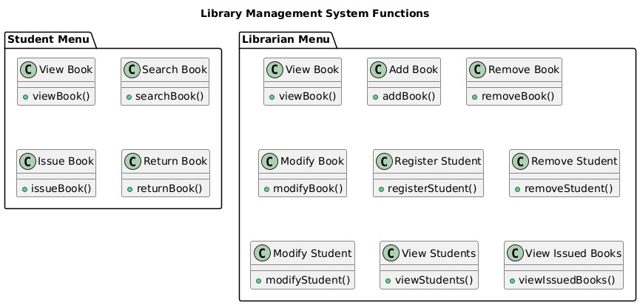

**OUTCOMES:**

* Technical Skills Development:
  + - Gained experience in database management, backend development, and user interface design.
* Practical Problem Solving:
  + - Learned to address real-world challenges like resource tracking, data consistency, and user access control.
* Improved Efficiency:
  + - Provide a solution to streamline library operations, saving time and reducing errors.
* Team Collaboration:
  + - Enhanced teamwork and communication skills of working in a group setting.
* Scalability Insights:
  + - Understand the challenges of designing scalable and user-friendly systems.

**FUTURE WORK:**

* Advanced Features:
  + - Add code based book tracking and categorization.
    - Add fingerprint based attendance system for employees.
* Scalability:
* Deploy the application on browser for easy access.
* Advanced Reporting and Analytics:
* Develop dashboards for tracking usage patterns, overdue books, and user activity.
* Support for Multi Languages:
* Add multilingual support to cater to diverse user bases.